## Merchant

Demo date: Nov 15, 2024  
Scoping start date: Dec 9, 2024

MSA Signature Date: Dec 30, 2024  
Onboarding Kick Off Date: Jan 7, 2025

[If Exists] Opt Out Date: none  
Go Live Date: Feb 10, 2025

GTM POC: Ben  
Implementation POC: Royce[Daniela Araya Molina](mailto:daniela@tabsplatform.com)

ERP: Other - Xero

Tax Integration: Anrok

### 

### Key people at Merchant

### [Eli Geschwind](mailto:eli@numeric.io) - Business Operations

* Ben Sheridan - Accountant
* Parker Gilbert - CEO and Co-founder
* Chris

### 

| Notes Sections [Ops International Team to Ignore] *(AE/ Implementation to fill)*   * Info on how merchant bills   + ~300 customers.   + Invoices: Predominantly annual (80%) with some multi-year/month-to-month contracts.   + Mid-to-high five-figure enterprise contracts, charged per seat, with plans to include transaction-based billing and overages.   + Payment Methods: Mostly ACH with some credit card   + Most contracts today are more fixed fee   + They are launching a new usage based pricing model that is critical for renewals and future scalability (key lever for 2025).   + IMPORTANT TO NOTE: they are Xero users      * Is there any important merchant relationship information? Merchant could be a great potential partner to Tabs, our businesses have a lot in common.   1) What is the merchant temperament?  Generally good, have mostly been working with Eli  2) Is there a key POC: (i.e.: who is the buyer/decision maker?)  Eli was our Champion, Parker signed the contract but has not otherwise been involved  3) What are the Tabs features that the key POC cares about?  Need: System to support granular and flexible new pricing models (esp usage).  Nice-to-Have: Additional capabilities like advanced reporting and forecasting. |
| --- |

### 

focusCompany summary  
*(AE to fill)*

What They Do:

Numeric.io is an AI-powered accounting automation platform that simplifies financial operations for businesses. It streamlines processes like reconciliations, close management, revenue recognition, and provides AI-driven financial insights.

Numeric operates on a subscription model with tiers for small businesses, growing companies, and custom solutions for enterprises. It helps clients save time and reduce costs by automating manual accounting workflows and offering advanced financial reporting.

Numeric recently raised $28M in a Series A led by Menlo Ventures, with support from IVP, Socii Capital, Founders Fund, and others, to expand its platform and scale operations.

Goals (North star)  
*(AE/ Implementation to fill)*

What is the merchant's goal? What pain are we solving? Why are they buying Tabs?

**Numeric's Goals:**

Streamline Financial Operations:

Automate manual processes like revenue recognition, invoicing, and tracking renewals to reduce errors and improve efficiency.

Support New Pricing Models:

Transition from a seat-based model to more flexible pricing that includes transaction-based billing, overages, and advanced features like tiered pricing and prepaid commitments.

Enhance Reporting and Forecasting:

Provide more accurate insights into metrics like committed ARR (CARR), renewals, and revenue growth to enable better decision-making.

Prepare for Scalability:

Implement a future-proof system that can handle increasing customer volume and complexity as Numeric grows its client base and revenue streams.

**Pain Points Solved:**

Manual Workload:

Numeric’s current reliance on spreadsheets for revenue recognition, renewals, and pricing adjustments creates inefficiencies and increases the risk of errors.

Inflexible Tools:

Existing systems like Stripe and Xero struggle to support usage-based billing, tax calculation, and granular pricing adjustments, limiting their ability to evolve their billing models.

Delayed Data and Insights:

Current processes lack the automation and reporting needed to track critical metrics like user increases, renewals, and transaction data in real-time, making it hard to forecast and optimize revenue.

Scalability Challenges:

Numeric’s 300+ customers with mid-to-high five-figure contracts require a solution that can grow with them while reducing the burden on their operations team.

Is there an opt out clause? If so, what is the merchant looking for so they do not exercise it?

### Billing model *(AE/ Implementation to fill)*

* Are there unique things about the customer creation process for this merchant?
* Information on how merchant bills

Mid-to-high five-figure enterprise contracts, charged per seat, with plans to include transaction-based billing and overages.

New pricing model includes usage that will be pulled from Retool. Usage is fairly simple thus far (eg. customer has 1 client on Netsuite and 5 clients on QBO)

* How contract is broken up
* One off things to know about the merchant

### 

### Contract Processing Steps *(Implementation/Success to fill)*

Numeric has different varying contracts, their order forms are standard but have varying details

* **Implementation Fees (**please note if there is a discount. A discount will get processed as its own line item) [Garage example here](https://garage.tabsplatform.com/prod/contracts/f8c58bb9-fb48-458e-bd0b-8429115d0c53/terms/revenue)

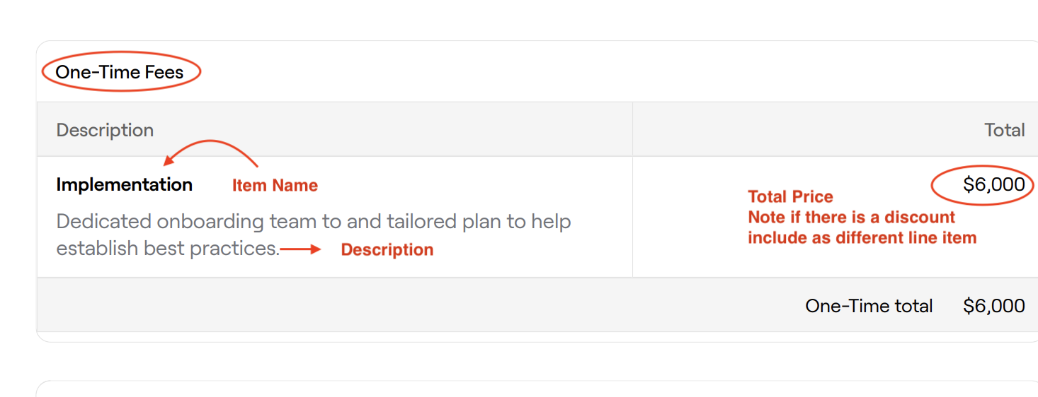

* + Service Start Date: Same as contract start date
  + Months of Service: Same as contract length
  + Item Name: View screenshot example above
  + Item Description: Whole entire description listed in screenshot above
  + Integration Item: NONE
  + Billing type: Flat
  + Total Price: listed in contract, if there is a discount create one positive line item for full price and then another line item with a negative price for discount
  + Quantity: one
  + Start Date: Same as contract start date
  + Periods : 1
  + Frequency: length of contract, default 1 year
  + Net Terms: Listed under **payment terms** in contract
* **Recurring Fees** (keep an eye out for invoice schedules as they often vary from contract to contract)

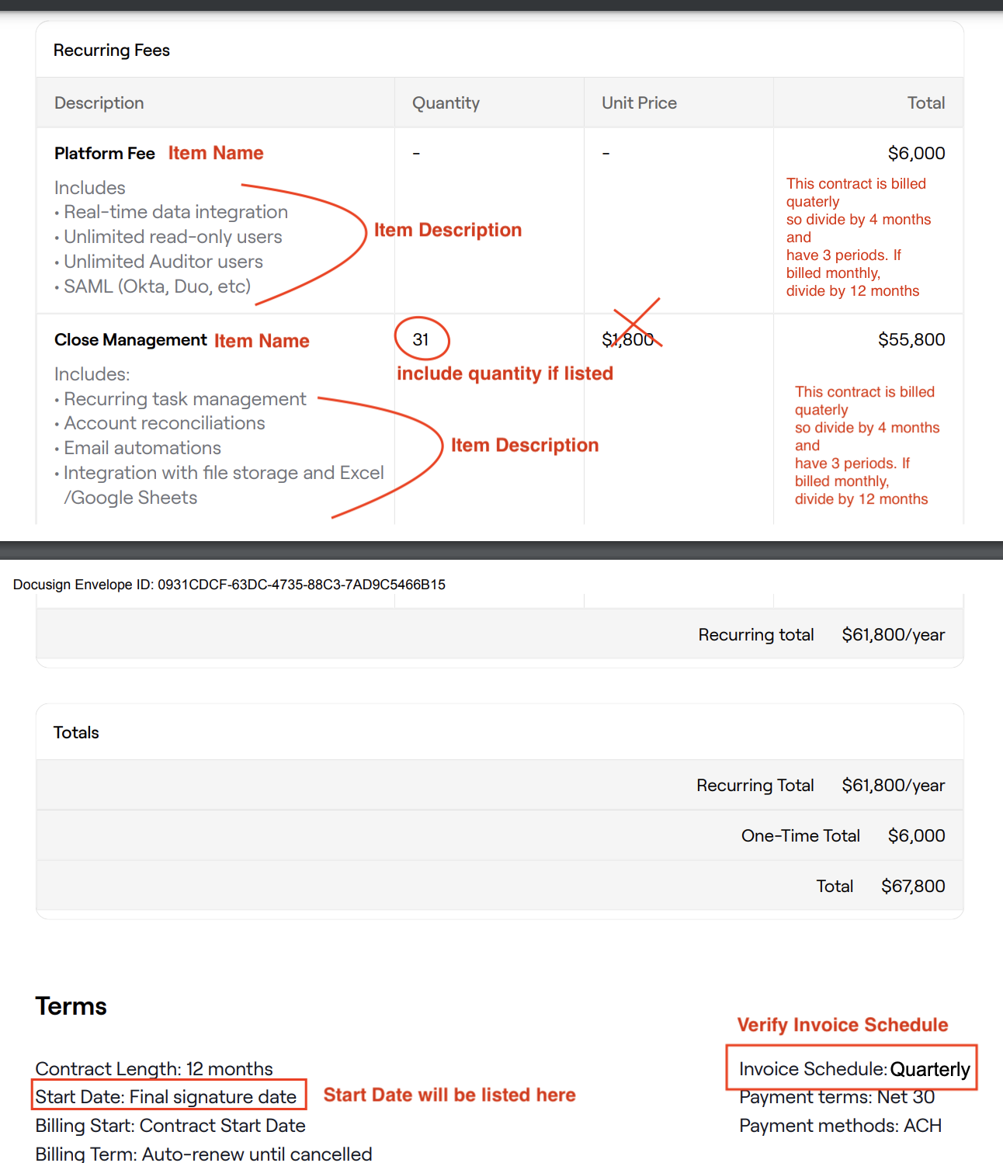

* + Service Start Date: Listed in contract, see screenshot above
  + Months of Service: Listed in contract, under contract length see screenshot above
  + Item Name: Item name will be bolded ideally
  + Description: Copy and paste the description, verify that it copies with no errors
  + Integration Item: NONE
  + Billing type: Flat
  + Total Price: Depending on invoice cadence, take the total prices listed and divide accordingly
  + Quantity: Always include the quantity listed
  + Start Date: same as contract start date
  + Periods: Depends on billing. If billed monthly put 12. If billed quarterly, put 4.
  + Frequency: Put 1 monthly if billed monthly, put 3 if billed quarterly
  + Net Terms: Find under Payment terms in screenshot above as example
* Other requirements
  + **Fill out billing address on merchant app** 
    - See where to find in screenshot below

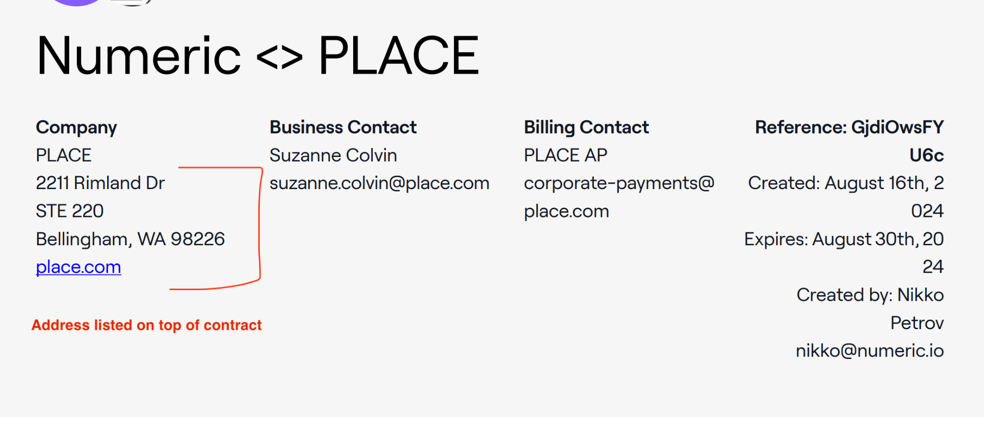

* **Additional Fields** 
  + Fill out Sales Representative (will be included with image of sales rep, and their Name) See screenshot below

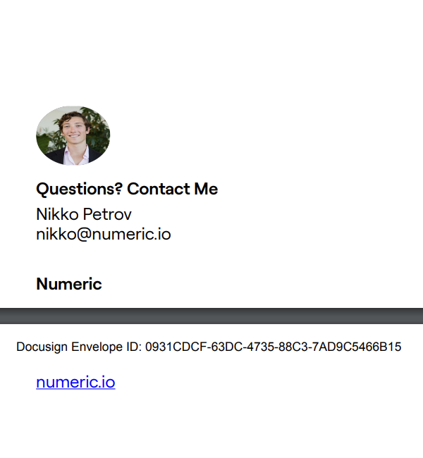

1. Anything to ignore in contracts?
2. Specifics processing things the merchant has requested that may differ by contract (e.g. always back-date invoice date to final day of the month)
3. Default Service Term
   1. If None Listed, Ops Default is 1 Year
4. Default Net Payment Terms
   1. If None, Ops Default is 0
5. Default Billing Frequency
   1. If None Listed, Ops Default is Monthly
6. How do we handle taxes as a line item?
   1. If None Listed, Ops Default is every tax line item becomes a BT

### Events Processing (if necessary) *(Implementation/Success to fill)*

* Any important information on events billing

Integration Items Processing (if necessary)  
*(Implementation/Success to fill)*

* What are the instructions for assigning integration items?
* Example: All Statsig integrations items should be labeled as “Sales”
* Example: All “Pinata” integration items should be labeled as “Software Subscription Bundle” unless otherwise noted by Merchant

Post Processing Communications (if necessary)  
*(Implementation/Success to fill)*

* Does the Ops Team need to notify anyone on the team re: completion of processing batches in Implementation or Active phase?
* Who needs to be notified and when?
  + Example:
    - Who: Customer Success [Azmat Aziz] needs to be notified
    - Where: Messari internal merchant channel
    - When: contracts are processed [Merchant Phase: Active]

### Customer Information *(Implementation/Success to fill)*

* Any important information on specifics customers of this merchant
  + Special memo’s certain invoices require
  + Invoice changes due to merchant/customer relationship

### Feature Requests *(AE/Implementation/Success to fill)*

* FR 1
  + What is it
  + Why it's important
  + Urgency

### Rewatch Calls *(AE/Implementation/Success to fill)*

* <https://www.loom.com/share/212bbc42a7cf499fa2c697bffda16424>
* Tabs Numeric Scoping call w/ Royce (Xero Integration discussed) <https://www.loom.com/share/74db8bafdd9543d2b674de76ca394e12>